**AT Commands**

**What you should know**

Different phones support different sets of AT commands. This means that a specific phone might not support all AT commands listed below. Currently there is no authoritative list available of supported AT commands by all phones.

**Overview**

AT commands are also known as Hayes AT commands. There are different views to understand the meanings of "AT". Some call it "Attention Telephone", whereas others interpret it as "Attention Terminal" commands.

AT commands allow giving instructions to both mobile devices and ordinary landline telephones. The commands are sent to the phone's modem, which can be a GSM modem or PC modem. This article focuses on AT commands on Nokia's GSM and WCDMA products only. Different manufacturers may have different sets of AT commands. Fortunately, many AT commands are the same. Mobile device manufacturers may also give attention to operators to allow or not to allow some commands on phones.

AT commands can be used for operations that are usually done from the keypad, for instance calling a number, sending, reading, or deleting an SMS, setting the SMSC number, looking for a GPRS access point, reading and deleting phonebook data, reading the battery status, reading the signal strength, and so on. When you want to make a PC-based application to interface a mobile phone using USB, IR, or Bluetooth, these commands are needed to communicate with mobile phones. Basically such commands are the application layer of MBUS or FBUS commands. Nokia provides an AT command set guide, where you can see the basic command syntax and the response of the command in various situations. See the Related Links section at the end of this article).

**Using AT Commands with HyperTerminal**

AT commands work on devices that have a built-in GSM modem. If there is one, you do not need to install virtual modem software on your PC. If you are using very old Nokia devices, you have to find out the DATA suite, not the PC Suite, for these devices (such as the Nokia 5110) to be able to use AT commands. This article focuses on mobile devices that have a built-in GSM modem.

To use AT commands:

* Connect the mobile phone to your PC in PC Suite mode using any available connection (Bluetooth, USB, or IR).
* Make sure that you have installed the correct GSM modem driver on your PC. You can check it from Control Panel | System | Hardware | Device Manager. Check the Modems section. If you see something like "Nokia XY USB Modem" or "Nokia XY Bluetooth Modem", the device has a built-in GSM modem. If you don't have it, go to the Nokia Web site and download the driver from the product page of your device.

[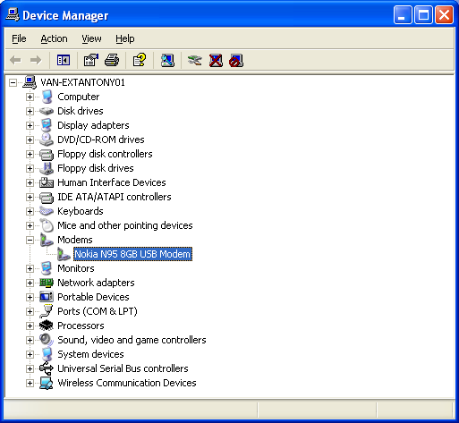](http://www.developer.nokia.com/Community/Wiki/File:Controlpanel_gsmmodem.png)

* Right Click on Nokia N95 8GB USB Modem and find the port used by selecting the modem tab, in our case it is COM 4. Also it is good to test the modem by selecting Diagnostics | Query Modem, this will tell us if the modem is working properly.
* Open the HyperTerminal, which is a communication utility on Microsoft Windows OS. HyperTerminal is located in Start | Programs | Accessories | Communication.
* Create a new connection set on HyperTerminal and give a name to the connection.
* Select the port number by selecting drop down box "Connect using". In our case the port number is COM 4

[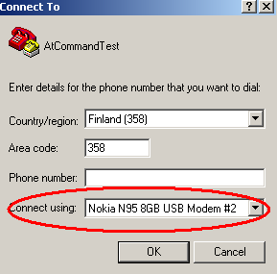](http://www.developer.nokia.com/Community/Wiki/File:Selectportatcommand.png)

* You need to select some settings related to ASCII setup, To do select File | Properties | Settings (tab) | ASCII Setup

[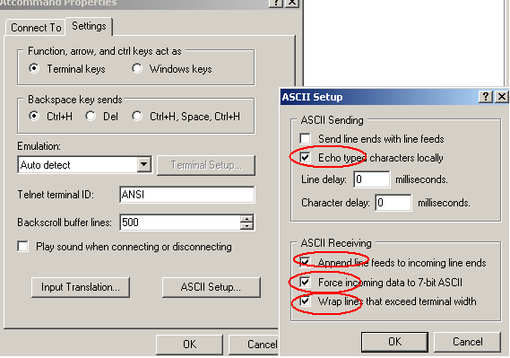](http://www.developer.nokia.com/Community/Wiki/File:Asciisetup.png)

* You may need to set some parameters, such as baud rate (for example, 9600), handshaking mode (Xon-Xoff), parity bit (default), and so on.

|  |  |
| --- | --- |
| [Hyperterminal settings.png](http://www.developer.nokia.com/Community/Wiki/File:Hyperterminal_settings.png) | * Note that you also need to select the communication port on which your mobile has been connected. The port number can be found by right-clicking the modem item in Control Panel. |

|  |  |
| --- | --- |
| [Controlpanel gsmmodem port.png](http://www.developer.nokia.com/Community/Wiki/File:Controlpanel_gsmmodem_port.png) | * After this, you can give the basic AT command. Simply type **AT** in the window and you will get the "OK" response. |

[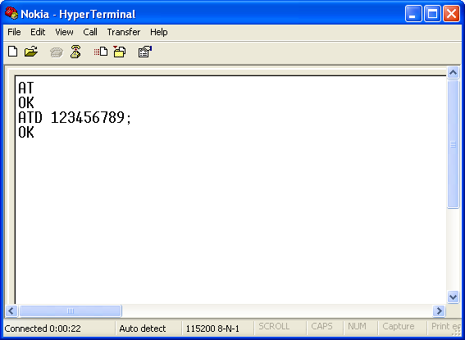](http://www.developer.nokia.com/Community/Wiki/File:Hyperterminal_example.png)

The above picture also shows how to dial a number using the ATD command. Note that there is a semi-colon (;) at the end of the phone number indicating that this is a voice call. If there is no semi-colon, a data call (CSD call) is will be performed.

**AT commands set for Nokia GSM and WCDMA products**

**Call control**

|  |  |
| --- | --- |
| **Command** | **Description** |
| ATA | Answer command |
| ATD | Dial command |
| ATH | Hang up call |
| ATL | Monitor speaker loudness |
| ATM | Monitor speaker mode |
| ATO | Go on-line |
| ATP | Set pulse dial as default |
| ATT | Set tone dial as default |
| AT+CSTA | Select type of address |
| AT+CRC | Cellular result codes |

**Data card control commands**

|  |  |
| --- | --- |
| **Command** | **Description** |
| ATI | Identification |
| ATS | Select an S-register |
| ATZ | Recall stored profile |
| AT&F | Restore factory settings |
| AT&V | View active configuration |
| AT&W | Store parameters in given profile |
| AT&Y | Select Set as power up option |
| AT+CLCK | Facility lock command |
| AT+COLP | Connected line identification presentation |
| AT+GCAP | Request complete capabilities list |
| AT+GMI | Request manufacturer identification |
| AT+GMM | Request model identification |
| AT+GMR | Request revision identification |
| AT+GSN | Request product serial number identification (IMEI) |

**Phone control commands**

|  |  |
| --- | --- |
| **Command** | **Description** |
| AT+CBC | Battery charge |
| AT+CGMI | Request manufacturer identification |
| AT+CGMM | Request model identification |
| AT+CGMR | Request revision identification |
| AT+CGSN | Request product serial number identification |
| AT+CMEE | Report mobile equipment error |
| AT+CPAS | Phone activity status |
| AT+CPBF | Find phone book entries |
| AT+CPBR | Read phone book entry |
| AT+CPBS | Select phone book memory storage |
| AT+CPBW | Write phone book entry |
| AT+CSCS | Select TE character set |
| AT+CSQ | Signal quality |

**Computer data card interface commands**

|  |  |
| --- | --- |
| **Command** | **Description** |
| ATE | Command Echo |
| ATQ | Result code suppression |
| ATV | Define response format |
| ATX | Response range selection |
| AT&C | Define DCD usage |
| AT&D | Define DTR usage |
| AT&K | Select flow control |
| AT&Q | Define communications mode option |
| AT&S | Define DSR option |
| AT+ICF | DTE-DCE character framing |
| AT+IFC | DTE-DCE Local flow control |
| AT+IPR | Fixed DTE rate |

**Service**

|  |  |
| --- | --- |
| **Command** | **Description** |
| AT+CLIP | Calling line identification presentation |
| AT+CR | Service reporting control |
| AT+DR | Data compression reporting |
| AT+ILRR | DTE-DCE local rate reporting |

**Network communication parameter commands**

|  |  |
| --- | --- |
| **Command** | **Description** |
| ATB | Communications standard option |
| AT+CBST | Select bearer service type |
| AT+CEER | Extended error report |
| AT+CRLP | Radio link protocol |
| AT+DS | Data compression |

**Miscellaneous commands**

|  |  |
| --- | --- |
| **Command** | **Description** |
| A/ | Re-execute command line |
| AT? | Command help |
| AT*C | Start SMS interpreter |
| AT*T | Enter SMS block mode protocol |
| AT*V | Activate V.25bis mode |
| AT*NOKIATEST | Test command |
| AT+CESP | Enter SMS block mode protocol |

**SMS commands**

**SMS text mode**

|  |  |
| --- | --- |
| **Command** | **Description** |
| AT+CSMS | Select message service |
| AT+CPMS | Preferred message storage |
| AT+CMGF | Message format |
| AT+CSCA | Service centre address |
| AT+CSMP | Set text mode parameters |
| AT+CSDH | Show text mode parameters |
| AT+CSCB | Select cell broadcast message types |
| AT+CSAS | Save settings |
| AT+CRES | Restore settings |
| AT+CNMI | New message indications to TE |
| AT+CMGL | List messages |
| AT+CMGR | Read message |
| AT+CMGS | Send message |
| AT+CMSS | Send message from storage |
| AT+CMGW | Write message to memory |
| AT+CMGD | Delete message |

**SMS PDU ode**

|  |  |
| --- | --- |
| **Command** | **Description** |
| AT+CMGL | List Messages |
| AT+CMGR | Read message |
| AT+CMGS | Send message |
| AT+CMGW | Write message to memory |